# Overview

Upon completion of this chapter, the participant will be able to:

* Differentiate between enterprise resources and local resources.
* Build a team of resources from the enterprise resource pool.
* Display generic resources in the enterprise pool and add them to the team.
* Apply two different approaches to assigning resources to tasks and be able to point out the advantages of each approach.
* Identify when a resource overallocation exists on a task.
* Evaluate the availability of a resource to do work on your project before adding them to your project team.
* Evaluate the availability of a resource from your project team before adding them to a task.
* Display workload and overallocation across projects using multiple views.
* Apply techniques to solve overallocations.
* List the benefits of Team Planner view.

# Project Professional Resource Management

An important distinction between managing resources with Project Professional (Project Pro) and managing resources with PWA is that in Project Pro, you are managing task schedule assignments only. With Project Pro, you don’t have the ability to manage the Resource Plan or the SharePoint Task list assignments. With Project Pro’s advanced scheduling features, you have many more ways to create and edit task assignments and many easy ways to manipulate views to show the exact resource details you need very quickly.

Project Pro is the optimized interface for assigning multiple resources to multiple tasks, and for providing multiple resource availability options within the assignment process. Following this section, you will have a better idea of when to use Project Pro to manage your resource assignments.

A reminder: only the project owner has the capability to edit a schedule in Project Pro and manage its resource assignments.

In this section, we will assume that you are using Project Pro connected to Project Server. We will also assume that you are not using Project Pro in any other modes which have alternative benefits.

## Local Resources vs. Enterprise Resources

Enterprise Resources are created by the administrator and represent a person, role, skill set, material, or other cost that is driven by its use to accomplish a task in the project. Normally an organization will create named enterprise resources to represent a person who will be performing work and generic enterprise resources to represent a role or skill set for resource planning. The collection of all enterprise resources is referred to as the enterprise resource pool. Using an enterprise resource ensures there is a representation of that resource that all project managers and schedulers should refer to.

If you want to display resource assignments across the enterprise, you must use enterprise resources. Enterprise resources are added to each project as needed.

Some organizations have enabled Local Resources (a Project Pro only feature) which allow a project manager or scheduler to add a unique resource to a project. A local resource is never added to the enterprise resource pool or available in centralized reporting (such as the Resource Center in PWA).

The advantage of local resources is that they are one-time resources that can be accounted for in the project schedule, but the project manager does not have to go through the more involved, formal process of working with the administrator to get those resources set up in the enterprise resource pool. Normally, local resources are used for one-time vendors or temporary contract employees.

The disadvantage of local resources is that they will not be able to self-report status updates. This can put an extra burden on the project manager: someone must go out and ask for updates from each local resource and then manually enter them into the project schedule. Unfortunately, you will not know if another project manager has assigned their own personal local resource representing the same person in their schedule. Because of this, overallocation issues across projects are not visible.

You should check with your administrator if you are unsure of your ability to use local resources or to learn more about the recommended situations for using local resources on your projects in your organization.

Warning - Local resources cannot be turned into new enterprise resources.

To create a local resource:

1. Navigate to Project Professional.
2. In the File tab, click Open.
3. Click the Project Web App account name and click Browse. If necessary, double-click Show me the list of all projects. Click the desired project and click Open.
4. In the View tab, in the Resource Views group, click Resource Sheet.
5. In Resource Name, enter a local resource name and press Enter.
6. Make changes to any additional columns as desired and press Enter to accept the changes.
7. In the View tab, in the Task Views group, click Gantt Chart.

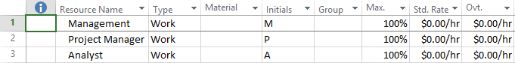

1. Resource Sheet [Resource Sheet.tif]

## Overview of Task Types

Task Types is an advanced task and resource planning feature for Project Pro scheduling. This feature is not available in PWA scheduling. Task Types allow you to set a combination of Task Type and Effort Driven options to control the calculations of related columns (such as Duration, Work, and Peak Units). The goal of this section is to introduce you to the concepts of working with Task Types and to provide best practices in planning a task and assigning resources.

Project Pro is set up for planning tasks by duration. This is the reason why there are question mark icons in each duration cell: they are a reminder that you did not enter a value for that task. The question mark symbol goes away after a number is entered. Typically, beginning users follow the approach of planning tasks by duration. If a schedule is created that will not use resources, planning tasks by duration is also the recommended approach.

With the introduction of resources into a project, your task estimating approach becomes important: as soon as a resource is assigned the scheduling engine performs a calculation.

The following scenarios will ensure that your preferred approach is applied when resources are assigned.

### Duration Based Estimating

Let’s say you would like to enter a duration value that remains constant regardless of the resources that are added or subtracted. This is called duration based estimating.

Some examples of tasks where duration based estimating is appropriate include:

* Attending a meeting
* Shipping time
* Cement curing

The length of time for these tasks are fixed and will not change based on the number of resources assigned.

The recommended practice is to estimate the duration of the task by entering a value into the Duration column, and then setting the value in the task **Type** column to Fixed Duration. Only then should you assign resources to the task.

This will cause total work for the task to be calculated.

The Effort Driven column provides a shortcut to equally divide the total work for the task across the resources assigned. This is useful for organizations that track costs or track resource assignments in detail.

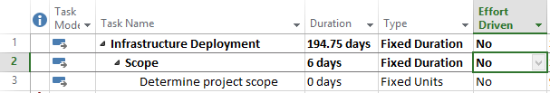

1. Entry Table with Duration and Optional Columns [Entry Table with Duration and Optional Fields.tif]

To follow this approach, insert the Type and Effort Driven columns in the Entry table of Gantt Chart view or display Task Entry view which provides these columns in the lower pane.

To Hide a Column:

1. Right-click the column heading and click **Hide Column**.

To Insert a Column:

1. Right-click the column heading and click **Insert Column**.
2. Click the desired column name.

You can type the first few letters of the column name to quickly filter the list.

You can also use the shortcut Add New Column on the far right side of the table.

### Work Based Estimating

You also have the choice to enter a total work value for the task that will remain constant regardless of the resources assigned. This is called work based estimating or effort-driven estimating.

Some examples of tasks where work based estimating is appropriate include:

* Development.
* Moving equipment.
* Eating a pie.

The amount of work it takes to complete the task does not change, but the work may be distributed across multiple resources who might be performing the task concurrently. Project will change the calculated duration of the task based on the number of resources assigned.

Even if you add a new resource or subtract a resource the total work hours will stay the same.

The column in Project is labeled Work, but it actually represents Total Work.

The recommended practice is to estimate the total hours the task will take to complete by entering a value in the Work column, and setting the value in the Task Type column to Fixed Work. Only then assign resources to the task.

The effort driven option is set to “Yes” automatically for Fixed Work tasks.

This will cause total duration for the task to be calculated.

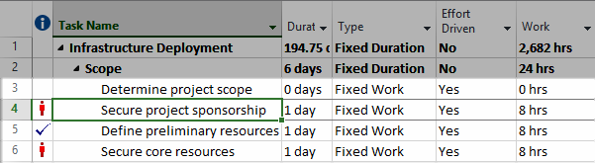

1. Entry Table with Work Column [ Entry Table with Work Field.tif]

To follow this approach, insert the Work column into the Entry Table of Gantt Chart view. This is where you will enter your total Work estimate.

Do not enter anything in the Duration column. This value is now being calculated based on the resources assigned.

For a more detailed discussion of Task Types, refer to the Advisicon books Introduction to Scheduling with Microsoft Project and Advanced Scheduling with Microsoft Project.

## Building a Team of Resources

As a project manager, you need to build a team of resources for each specific project. Project Pro’s Build Team from Enterprise feature allows you to build a team of resources from the Enterprise Resource Pool and use them for task assignments on the current project.

Although the entire Enterprise Resource Pool is available on every project, it is not efficient to continually update each project with the complete list. Doing so slows down system performance, including project publishing. The project team is a short list of resources that will be used for this one project specifically, and is more efficient for browsing project resources. Building a team is typically done right before assignments are made. Additional resources are added throughout the project when needed.

If you want your team of resources to include generic resources, refer to the Using Generic Resources.

To build a team of resources:

1. Navigate to Project Professional.
2. In the File tab, click Open.
3. Click the desired project and click Open.
4. In the Resource tab, in the Insert group, click the Add Resources dropdown and then click Build Team from Enterprise.

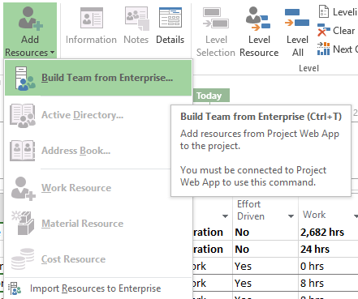

1. Add Resources List [Add Resources List.tif]
2. In the Build Team dialog box, select the desired Enterprise Resource(s) on the left and click Add from the middle section.

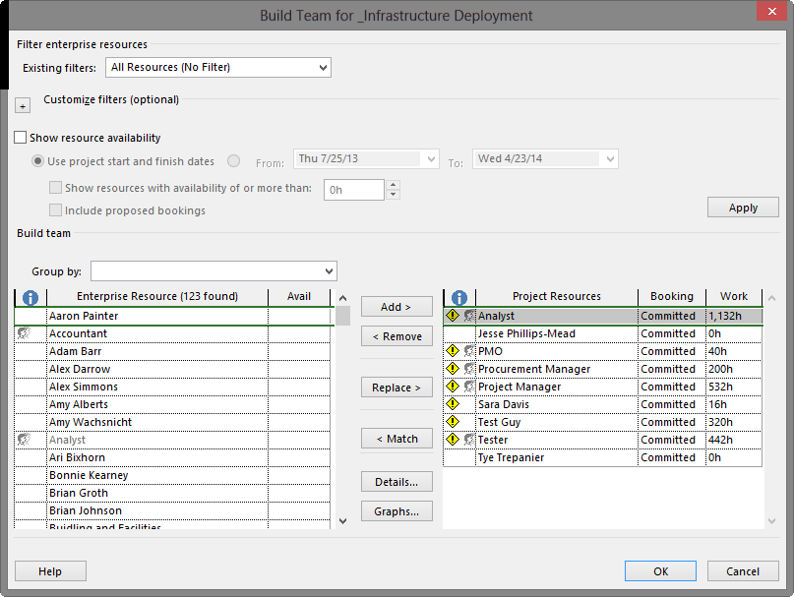

1. Build Team Dialog in Project Professional [Build Team Dialog in Project Professional.tif]
2. Click OK.

The resources you have selected for this project are listed on the Resource Sheet or on the right side of the Build Team dialog box.

## Using Generic Resources

A generic resource is a resource that has been created for the purpose of resource planning and it typically represents a job role, job title, or skill set. If you are unsure which individuals will be available for your project, you can select generic resources to help plan the resource needs for the project. Later, when you know who your resources are, these generic resources will be replaced with actual resources.

Generic resources are frequently used when planning activities that are far into the future or during the project proposal stage. Generic resources are selected from the Enterprise Resource Pool and added to your project.

Your project team can include both generic and named enterprise resources.

To build a team of generic resources:

1. Navigate to Project Professional.
2. In the File tab, click Open.
3. Click the desired project and click Open.
4. In the Resource tab, in the Insert group, click the Add Resources dropdown and then click Build Team from Enterprise.
5. In the Build Team dialog box, click the dropdown arrow next to Group by: and click Generic.
6. Under Enterprise Resources, click the minus (-) symbol next to No. Notice that this hides non-generic resources.
7. Select the desired generic Enterprise Resource(s) on the left and click Add.
8. Click OK.

## Assigning Resources with the Resource Names Column

Assigning resources to tasks is the process of picking resources from the project team to work on specific tasks. Assignments allow team members to view tasks they have been assigned on their Tasks page in PWA.

To assign resources to tasks:

1. Navigate to Project Professional.
2. In the File tab, click Open.
3. Click the desired project and click Open.
4. In the Task tab, View group, click Gantt Chart.
5. Scroll or drag the dividing bar until the Resource Names column is visible.
6. For the desired task, in the Resource Names cell, click the drop-down list and click the checkmark next to the desired resources you want to assign to the task.

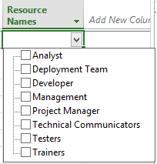

1. Resource Names Task Assignment Dropdown List [Resource Name Drop Down.tif ]

## Assigning Resources with the Assign Resources Dialog Box

While using the Resource Names column is a very efficient method for making assignments, it is a very slow process when multiple resources need to be assigned to multiple tasks. The Assign Resources dialog is more efficient for complex assignments. This dialog box also visually provides other information such as who is currently assigned to the task and any calculated resource costs.

To assign resources to tasks using the Assign Resources dialog box:

1. Navigate to Project Professional.
2. In the File tab, click Open.
3. Click the desired project and click Open.
4. In the Task tab, View group, click Gantt Chart.
5. In the Resource tab, Assignments group, click Assign Resources.
6. Select the desired task(s) on the Entry Table in Gantt Chart view and select the desired resource(s) in the Assign Resources dialog box. Click Assign.
7. Repeat until all assignments have been made.

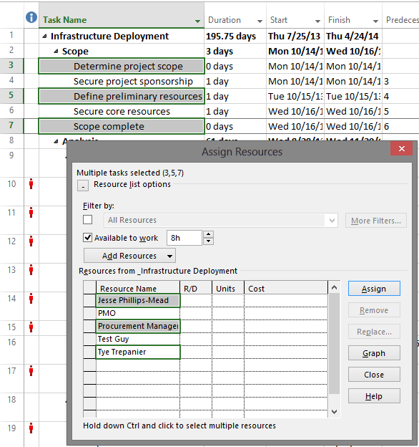

1. Assign Resources Dialog Used to Make Multiple Task Assignments [Assign Resources Dialog Box.tif]

The Assign Resources dialog box can remain open while you scroll through Gantt Chart view to locate desired tasks. This is a great timesaver.

Notice the checkmark that will appear next to resource names. This will indicate which resources are already assigned to the selected task.

## Checking Resource Availability

While reactive schedulers assign resources to tasks without regard for initial resource overallocation issues (hoping a solution can be found later), proactive schedulers evaluate resource availability during initial assignment. This section provides information about these approaches that can be used when resource loading your schedule.

### Watching for New Overallocations

The reactive approach creates an assignment and looks for overallocation indicators.

You may be curious why Microsoft did not prevent you from intentionally overallocating resources. In some organizations, resource management is separate from project management. Preventing a resource assignment to a task due to overallocation would restrict the scheduler’s ability to create a fully planned schedule for sharing with the resource manager.

Also, it might generate a lot of errors that could become frustrating.

To display new overallocations:

1. Navigate to Project Professional.
2. In the File tab, click Open.
3. Click the desired project and click Open.
4. In the Task tab, in the View group, click Gantt Chart.
5. Confirm that the Indicators column is showing
6. Assign a resource using your preferred method.
7. Watch the Indicators column for the red overallocation indicator (stick figure person)

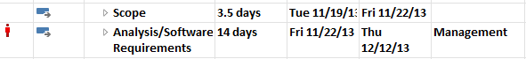

1. Overallocation Indicator in Entry Table [ROGG Example.tif]

### Build Team Dialog Box

At Advisicon, we recommend that you use the Build Team dialog box if you want to check resource availability at the project level before choosing a resource for your project team.

To check for project availability:

1. Navigate to Project Professional.
2. In the File tab, click Open.
3. Click the desired project and click Open.
4. In the Resource tab, in the Insert group, click the Add Resources dropdown and click Build Team from Enterprise.
5. In the Build Team dialog box, click the checkbox Show resource availability, select the desired options and then click Apply.
6. In the Build Team dialog box, select the desired Enterprise Resource(s) on the left and click Add.
7. To display all resources again, uncheck the checkbox and click Apply.
8. Click OK to accept team changes.

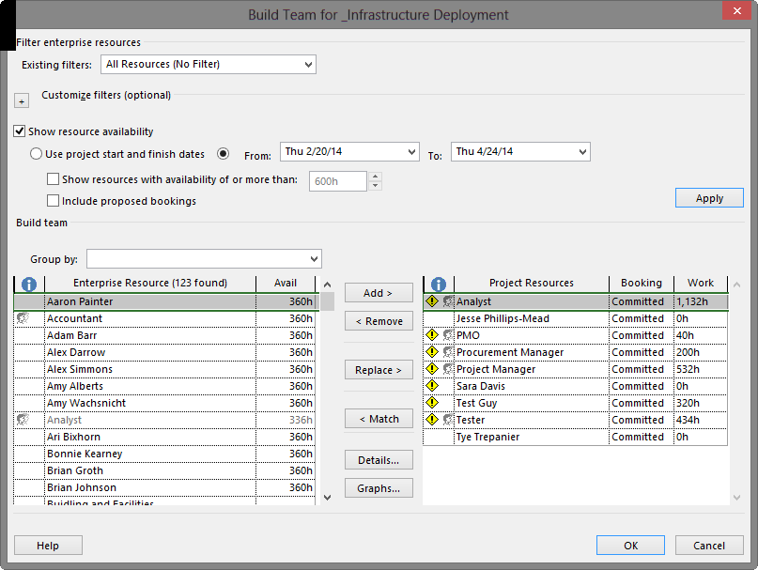

1. Assign Resources Filtered by Resource Availability for a Task [Assign Resources Filtered by Resource Availability.tif]

### Assign Resources Dialog Box

If you want to check resource availability at the task level using resources already selected for your project team, we recommend that you use the Assign Resources dialog box.

To check for task availability:

1. Navigate to Project Professional.
2. In the File tab, click Open.
3. Click the desired project and click Open.
4. In the Task tab, View group, click Gantt Chart.
5. In the Resource tab, Assignments Group, click Assign Resources. The Assign Resources dialog opens.
6. In the Entry Table, select any cell in the task row you want to check for resource availability.
7. In the Assign Resources dialog box, click the checkbox for Available to work, enter a value for the number of hours you will need a resource during the timeframe of the task and press Enter.

The resource list will automatically be filtered to hide un-assigned, unavailable resources.

1. Select the desired task(s) on the Entry Table of the Gantt Chart view and select the desired resource(s) in the Assign Resources dialog box. Click Assign.
2. To display all resources again, uncheck the checkbox.

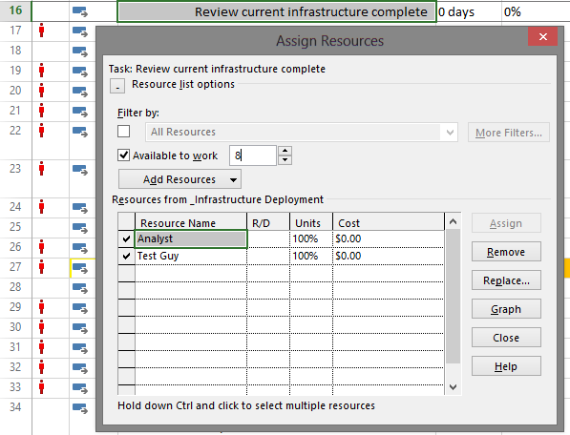

1. Build Team Filtered by Desired Resource Availability [Assign Resources ATW.tif]

## Publishing Assignments

Publishing a schedule does several things in Project Pro:

* It saves recent changes.
* It makes schedule changes visible to others and finalizes task assignments so resources can see their tasks in their Timesheet or Tasks page.
* It fully synchronizes information in the database. This is useful when a change saved in Project Pro is not showing up in PWA.

To publish assignments:

1. The schedule you wish to publish should already be open.
2. Click the File tab to display backstage view.
3. On the Info tab, click Publish.

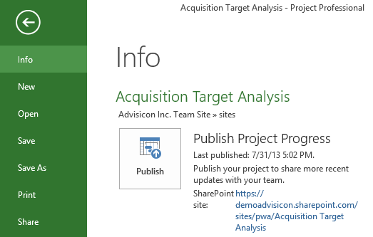

1. Publish in Backstage View [Backstage Publish.tif]

Be sure to watch the status of publishing on the status bar in the lower right corner. Wait until publishing is 100% complete to ensure the data has been fully synchronized with PWA.

## Managing Overallocations

Resource options in Project Pro include reviewing resource availability and assignments. Previously, we used a proactive approach to choose resources. Now we will use the powerful reviewing features in Project Pro to identify existing resource overallocations. We will manage those overallocations with various techniques. You can also refer to Finalizing a Project for additional ideas to resolve resource overallocations.

### Displaying Overallocations on Existing Assignments

Since we have connected Project Pro to Project Server, all resource assignment information is shared across the enterprise.

One of the advantages of reviewing resource assignments in Project Pro is that you can choose the level of detail you want to see. For example, when you need the 30000 foot view you can display the work on each project at a high level. When you need the 10000 foot view, you can show all the assignments on the projects the resources are working on. The level of detail is controlled by which projects you have open.

Another advantage of using Project Pro to review resource assignments is that you can have one or more schedules checked out for editing and immediately make changes that will resolve any resource overallocations across those schedules.

To display overallocations on existing assignments:

1. Navigate to Project Professional.
2. In the File tab, click Open.
3. Click the desired project and click Open.
4. In the Task tab, in the View group, click the Gantt Chart dropdown and select Resource Usage.
5. In the Usage table (left side) in the Add New Column dropdown, click Project.
6. In the timescale (right side) right click and click Overallocation.

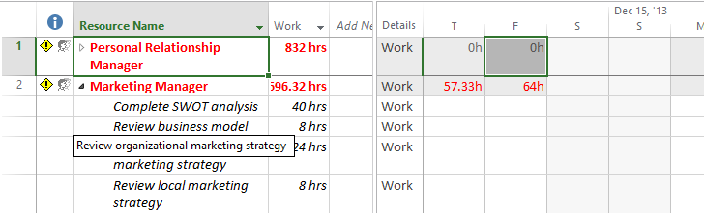

1. Resource Usage View [Resource Usage View.tif]

With Resource Usage view configuration done in this way, you can see the names of each resource assigned to work in the current project. Below the resource name will first be a line titled Other projects and commitments. If you expand this title, you will see a list of the names of any other projects that have assigned work to the resource.

Below Other projects and commitments there will be a list of tasks from the open project. You can use the Project column to confirm.

Notice that in the Resource Usage view the name of the project is in the Resource Name column, not a separate Project column. Should you want to see the actual tasks the resource is working on in the other projects, you will need to open those projects. Once the additional desired projects are opened, the Resource Usage view will automatically update.

On the right side of the Resource Usage view you can easily identify the amount of overallocation at specific points in time on tasks or projects. If you adjust the level of detail of the timescale, you can see a summary of overallocation for a block of time such as a month, or a quarter.

You can use the Resource Usage view to fix an overallocation or you can return to the Gantt Chart view to fix an overallocation. Some options for resolving an overallocation are listed below:

* Choose an alternate resource.
* Smooth the hours out across a time period to reduce the number of high and low points.
* Assign the resource as a part-time resource on multiple tasks.
* Postpone a task until a resource is available.
* Use Team Planner to further analyze (see Working with Team Planner View).
* Use leveling to allow the software to attempt to resolve the conflict.

For Project’s automatic leveling to be effective in Project Server, it requires that the project manager or scheduler have the ability to open and edit all other projects that the resource is working on. In most organizations, this is not the case. So, at Advisicon, we recommend our clients manually solve resource overallocations using other methods instead.

If a resource has been removed from your project, you can use the Build Team dialog box to replace all instances of the resource throughout your project. This feature will only replace the resource on remaining work, historical actuals will be preserved.

Some techniques to solve overallocations at the task level will be addressed in the next topic.

### Working with Team Planner View

While the Resource Usage view can help you see overallocation issues in the schedule, to correct these issues you must make adjustments to how the resources are assigned. That’s where Team Planner view shines.

Team Planner allows you to completely focus on the resource and make your adjustments so the task modification instantly responds. Team Planner is a feature that was first implemented in Project 2010. This view is a robust graphical view that displays the name of the task in the timescale (instead of having to follow a task row from one side of the screen to the other). Team Planner view has a simple to use drag-and-drop interface for resolving overallocations.

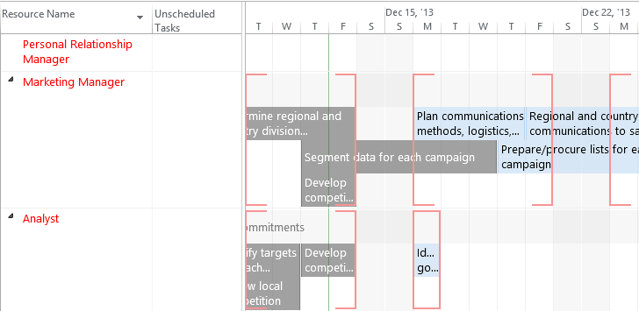

1. Team Planner View with Overallocated Resources [Team Planner View with Overallocated Resources.tif]

To display and correct overallocations using Team Planner view:

1. Navigate to Project Professional.
2. In the File tab, click Open.
3. Click the desired project and click Open.
4. In the Task tab, in the View group, click the Gantt Chart dropdown and click Team Planner.
5. Locate the overallocated resource and task you wish to make changes to.

* Hover on the task to view relevant details.
* Right-click on the task name to quickly reassign the task, delete it, or inactivate it.
* Double-click the task to view the Task Information dialog box and make any needed changes.
* Drag the task in team planner view to reassign or move the task to a locked in time period (sets a constraint)

1. In the File tab, click Publish to save the changes and share them with your project team via PWA.

Warning – If you see blank information within brackets on the right side of the view (the timescale), you will need to zoom out so the text crossing over multiple time periods can be displayed.

Double-click Other projects and commitments if you want to see the names of other projects your resources have been assigned to that are not currently open.

# Key Points to Remember

* Project Pro provides detailed resource management for specific task assignments in a schedule.
* Local resources (if available) do not provide any reporting across projects and their use should be limited.
* Consider the task type settings before making assignments to ensure the value you want to remain constant will be enforced.
* It is easier to manage multiple resources on a project by assigning them to a project specific team. This allows you to select appropriate resources for the project, rather than always dealing with the entire Enterprise Resource Pool every time resources are managed on a project.
* Generic resources are a mechanism for proactively resource planning on a project. This alerts the organization as to the types of resources that will be needed on the project and when named resources are ready to be assigned. In Project Pro, you can easily replace generic resources with enterprise resources.
* Assign resources using the Resource Names column when you want to create a single task assignment.
* Assign resources using the Assign Resources dialog box when you want to assign multiple resources to multiple tasks or to evaluate resource availability at a task level.
* Publish is required before information will be synced with PWA. Once Published, resources will see their assignments.
* Replacing named resources (rather than deleting and adding a new resource) on a project allows for preservation of historical information.
* The Indicators column shows a red overallocation indicator immediately when a resource assignment creates an enterprise overallocation.
* Resource Usage view and Team Planner view can be used to evaluate and make changes to overallocated resources.